Improve Commisions Process
Solutioning Sales Commission Logic & Statement Preparation

Sathish Kumar Rajendiran

Table of Contents
Executive Summary 2
A. Problem Statement 2
B. Business Impact 2
C. Goals 2
D. Project Scope 2
E. Team 3
F. Project Plan 3
G. Process map 3
Conclusion 4

Executive Summary
Accounting was seeking a solution to streamline the team’s month end commission payout process. The existing commission process required manual manipulation of accounting data in Excel spreadsheets that increased the risk of error. It was time consuming, frustrating, and detracted from more valuable aspects of accounting’s month end activities.

Problem Statement
We have a number of employees across the organization that receive a commission. Depending on the employee's commission type, they'll have a unique compensation plan that outlines the terms of their commission payments. The process and payment for each employee type is currently handled very differently and in disparate systems. This has caused instances where employees are incorrectly paid. In addition, commission statements provided to employees are often confusing and/ or incomplete.

Business Impact
Current process has complex calculation and often involves ad hoc adjustments. Thus, creating confusion in the commission statement and pay out. In addition, it also references several systems adding more complexity the process and resulted in 10s of thousands of dollars not getting paid to Account Executives (Sales Rep and their Managers) on time. Improving this process would certainly help AEs receive their commissions on time and having accurate commission statement.

Goals
Re-vamping the Commissions model to ensure 100% accuracy on Commission payments and having all the calculation logic built in centralized model. Provide, solutioning & recommendation to SalesOps to help achieve the results.

Project Scope
In scope: Work with Sales Ops to Understand, Document, Identify, Propose Solution. Handover the process/Solutioning to Sales Ops. This is for US region only.
Out of Scope: Defining the Commission Type, Mapping Employee to Sales Roles, Generating EIB file for accounting (Journal entries), Communication to AEs. Non-US regions are out of scope of this project.
First Step of the Process is to identify and map from the current process including,
- Commission Types
- Sales Rep hierarchy (AE, MD, VP, RVP etc.)
- Commission % or Benchmarking the range
- Commission Payout cycle
- Eligibility/ Qualification criteria

Last Step of the Process is to meet with SalesOps, Identify/evaluate measurement system in the current process, Ways to Calculate and incorporate SQL, summarize other pain areas if not discussed/included in the earlier (external factors impacting the current process)

Team
Accounting Team Owns the process; However, the request has come from SalesOps whose Account Executives and their Managers are heavily impacted on their monthly/Quarterly commissions.

Project Plan

End to end solutioning will be around 8 weeks. Please find the breakup below,
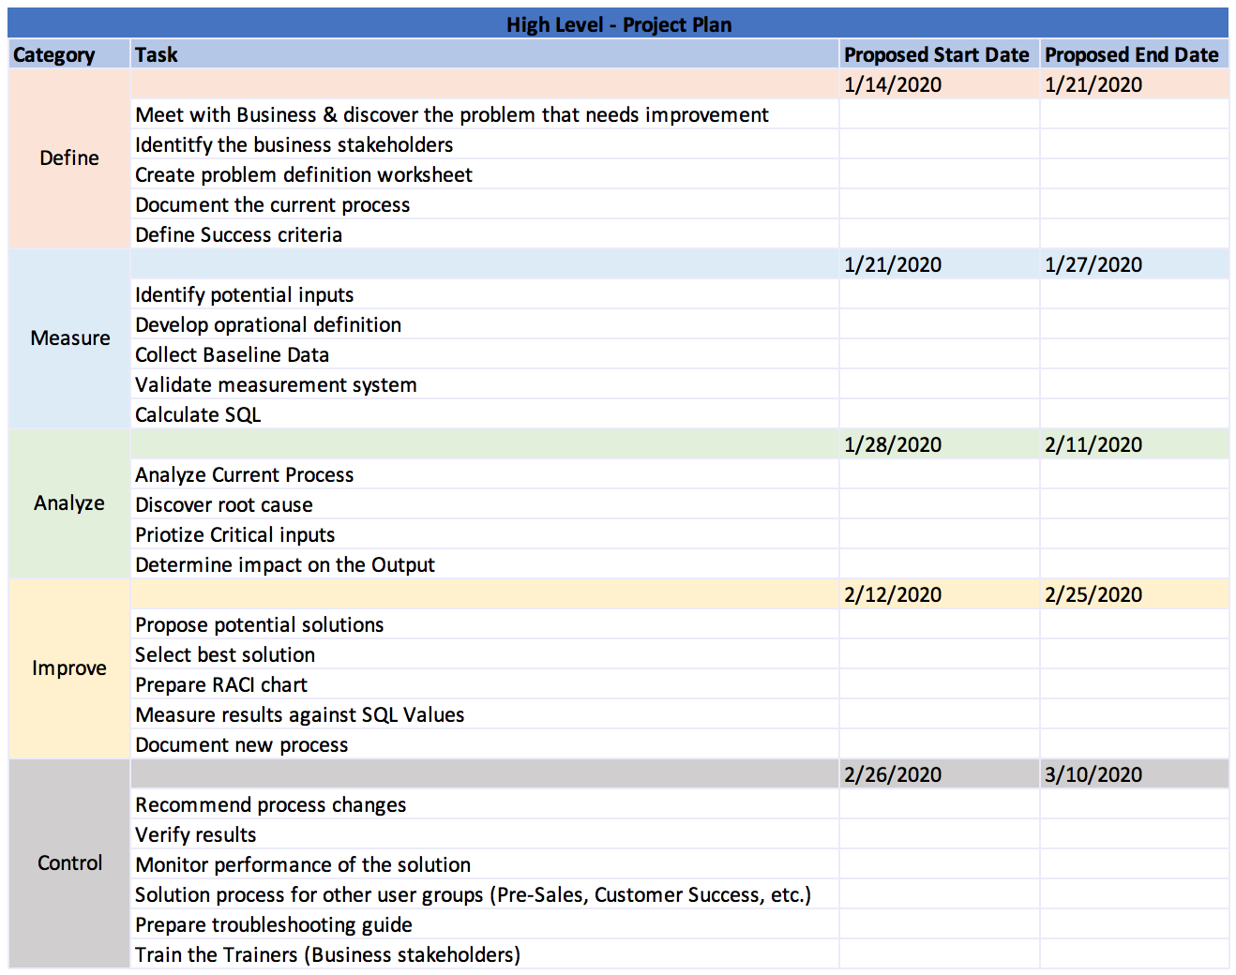

Process map
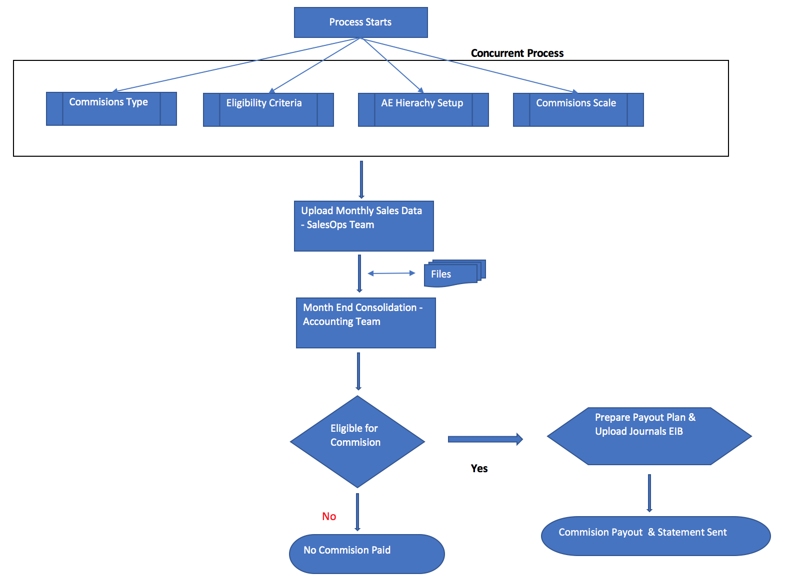

Conclusion
At the End, we would help maintain the integrity of the Commissions model and statement exports. A troubleshooting guide may also be included as a resource should any difficulty arise. Any issue is likely due to a missed step in the process.

